CS 255 Project Two: DriverPass System Design Document

Prepared by Gabriel Evans

UML Diagrams

UML Use Case Diagram
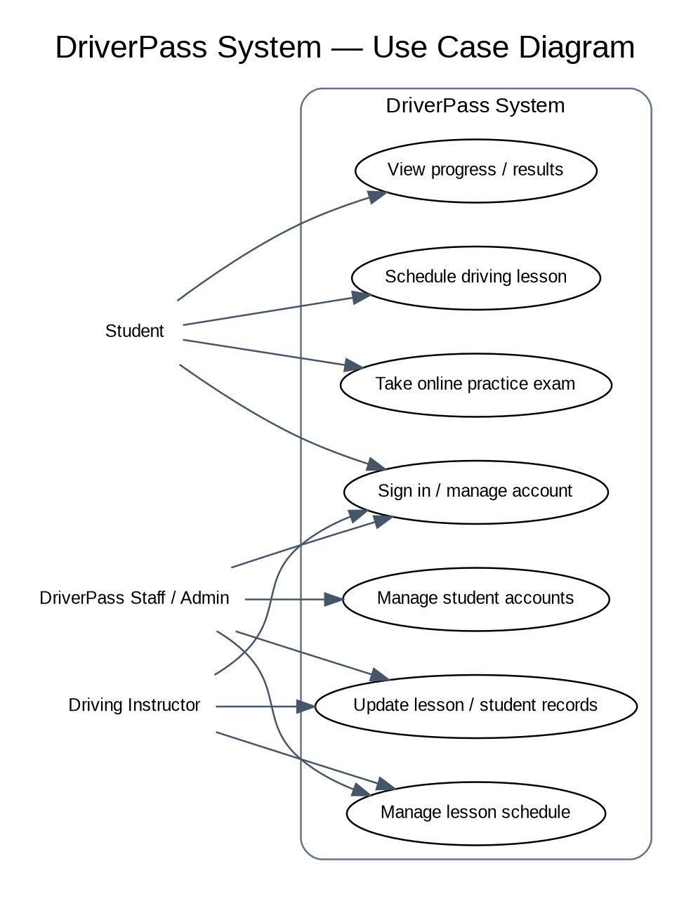

UML Activity Diagrams
Activity 1: Take Practice Exam
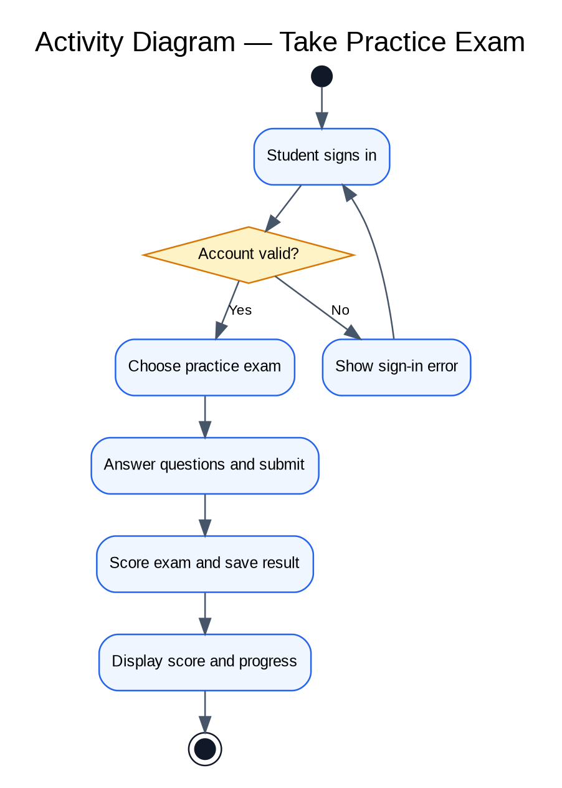
Activity 2: Schedule Driving Lesson
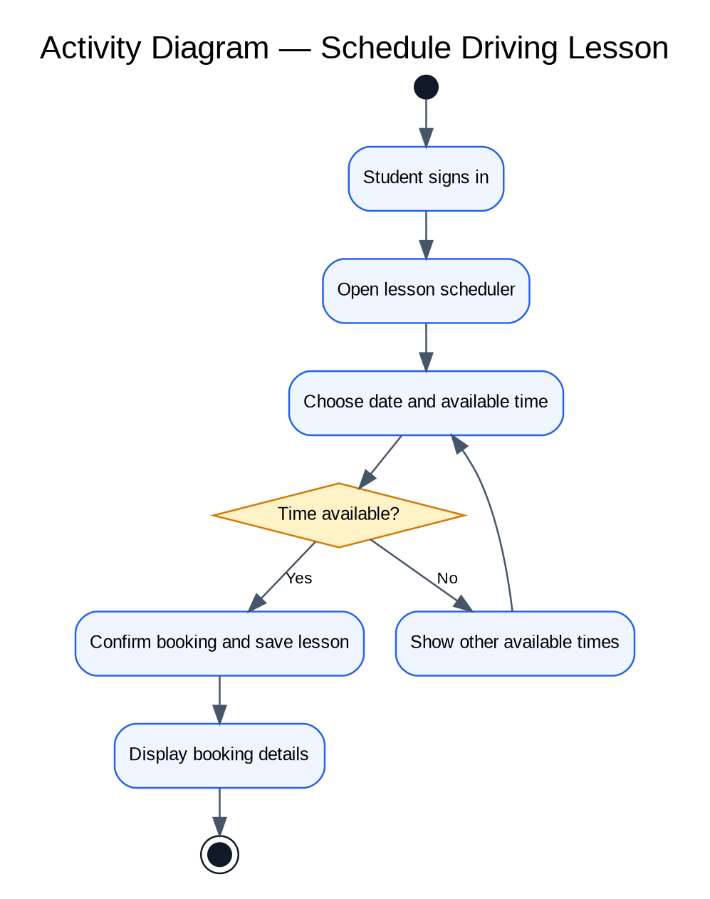

UML Sequence Diagram
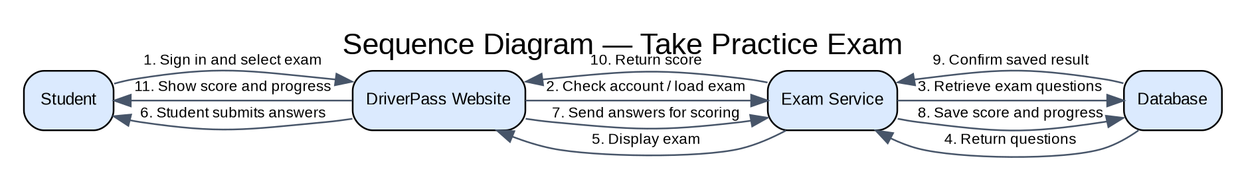

UML Class Diagram
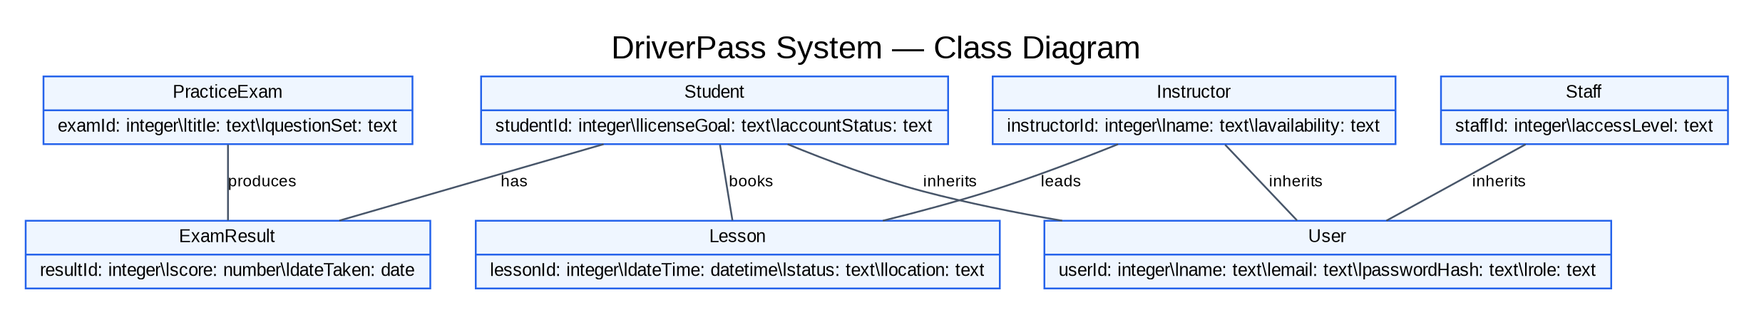

Technical Requirements
Hardware: Use reliable cloud hosting or a managed server with enough capacity for student accounts, exam activity, scheduling, and saved results. Staff need internet-connected computers. Students and instructors should be able to access DriverPass from a current computer, tablet, or smartphone with a supported web browser.
Software: The system needs a responsive website and application service for sign-in, practice exams, scoring, scheduling, and account management. A database will store user profiles, exam questions, scores, lesson bookings, and instructor availability. The website should support current versions of major browsers.
Tools and infrastructure: Developers can use Lucidchart for UML modeling and a source-control platform for managing code. A separate test environment should be used before changes go live. Hosting should include HTTPS, database backups, monitoring, and a recovery plan. The system should allow routine updates with minimal interruption.
Security and quality: Passwords should be stored as secure hashes rather than readable text. Role-based permissions should limit students, instructors, and staff to appropriate features. The system should validate submitted information and protect personal records. Testing should cover sign-in, exam scoring, scheduling conflicts, data recovery, browser compatibility, and performance during busy periods.
These are proposed technical requirements based on the assignment scenario. DriverPass should confirm final hosting capacity, vendors, and any payment or licensing integrations before implementation.

